Dual Careers Application 2018/19
Please complete the below criteria with as much detail as possible and then create a Vox Pop that introduces you, your sport and the reasons that you feel make you a suitable candidate for the programme. Please include how you would help to promote both the values of the college and the Dual Career Programme. This should last no longer than 15mins. The closing date for applications is Monday 24th Sept 10am.
Name:
Student Number:
DOB:
Courses Studied:

Sport Played:
Current Level:

Highest Achievement(s) to date:

Future targets:

Complete application forms and videos should be emailed to
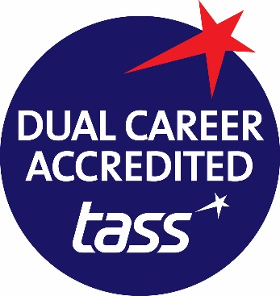
andrew.petch@nclt.ac.uk or danny.milnes@nclt.ac.uk

